Feb 2
No School
Brentwood Academy
2086 Clarke Ave
East Palo Alto, CA 94303
Cheryl Ousley, Principal

Brentwood Academy Mission Statement
The mission of Brentwood Academy is to empower the young minds of East Palo Alto through quality instruction and community outreach to create life-long learners.

COFFEE & DONUTS WITH THE PRINCIPAL!
Please join me Tuesday, January 14, 2020 @ 9:00 a.m. in the cafeteria!

SCHOOL ACCOUNTABILITY REPORT CARD (SARC)
A HARD COPY OF THE SARC WILL BE MADE AVAILABLE UPON REQUEST AT BRENTWOOD ACADEMY SCHOOL OFFICE.

Counseling Services:
If you would like your student to speak with a counselor at school or additional resources for mental health, please come to the main office and we can help you.

Upcoming Dates:
January 14th Coffee & Donuts w/Principal
January 20th MLK Holiday-No school
January 27th-31st^{h} The Great Kindness Challenge

Principal’s Notes

Welcome to 2020 Brentwood Families!
I hope this New Year will bring you lots of love, peace and prosperity!

As many of you are aware the Ravenswood Board of Trustees voted on Monday, January 9th to merge several of our elementary schools. In August 2020 Brentwood and Costano schools will merge and be located at the Costano site. Willow Oaks and Belle Haven will merge and be located at the Belle Haven site. You will hear more about the transition in the coming days from our District. We will continue our dedication and commitment to our scholars as well as continue to provide them with an optimal education.

Thank you for all that you do for our Brentwood Academy scholars! I am very thankful for you! Happy New Year!

Ms. Ousley, Principal

Principal’s Newsletter
January 2020

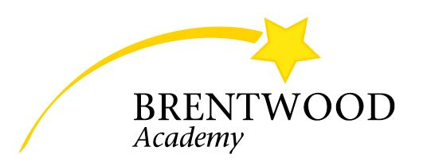

Oct 30
Fall Festival

